Spring Security

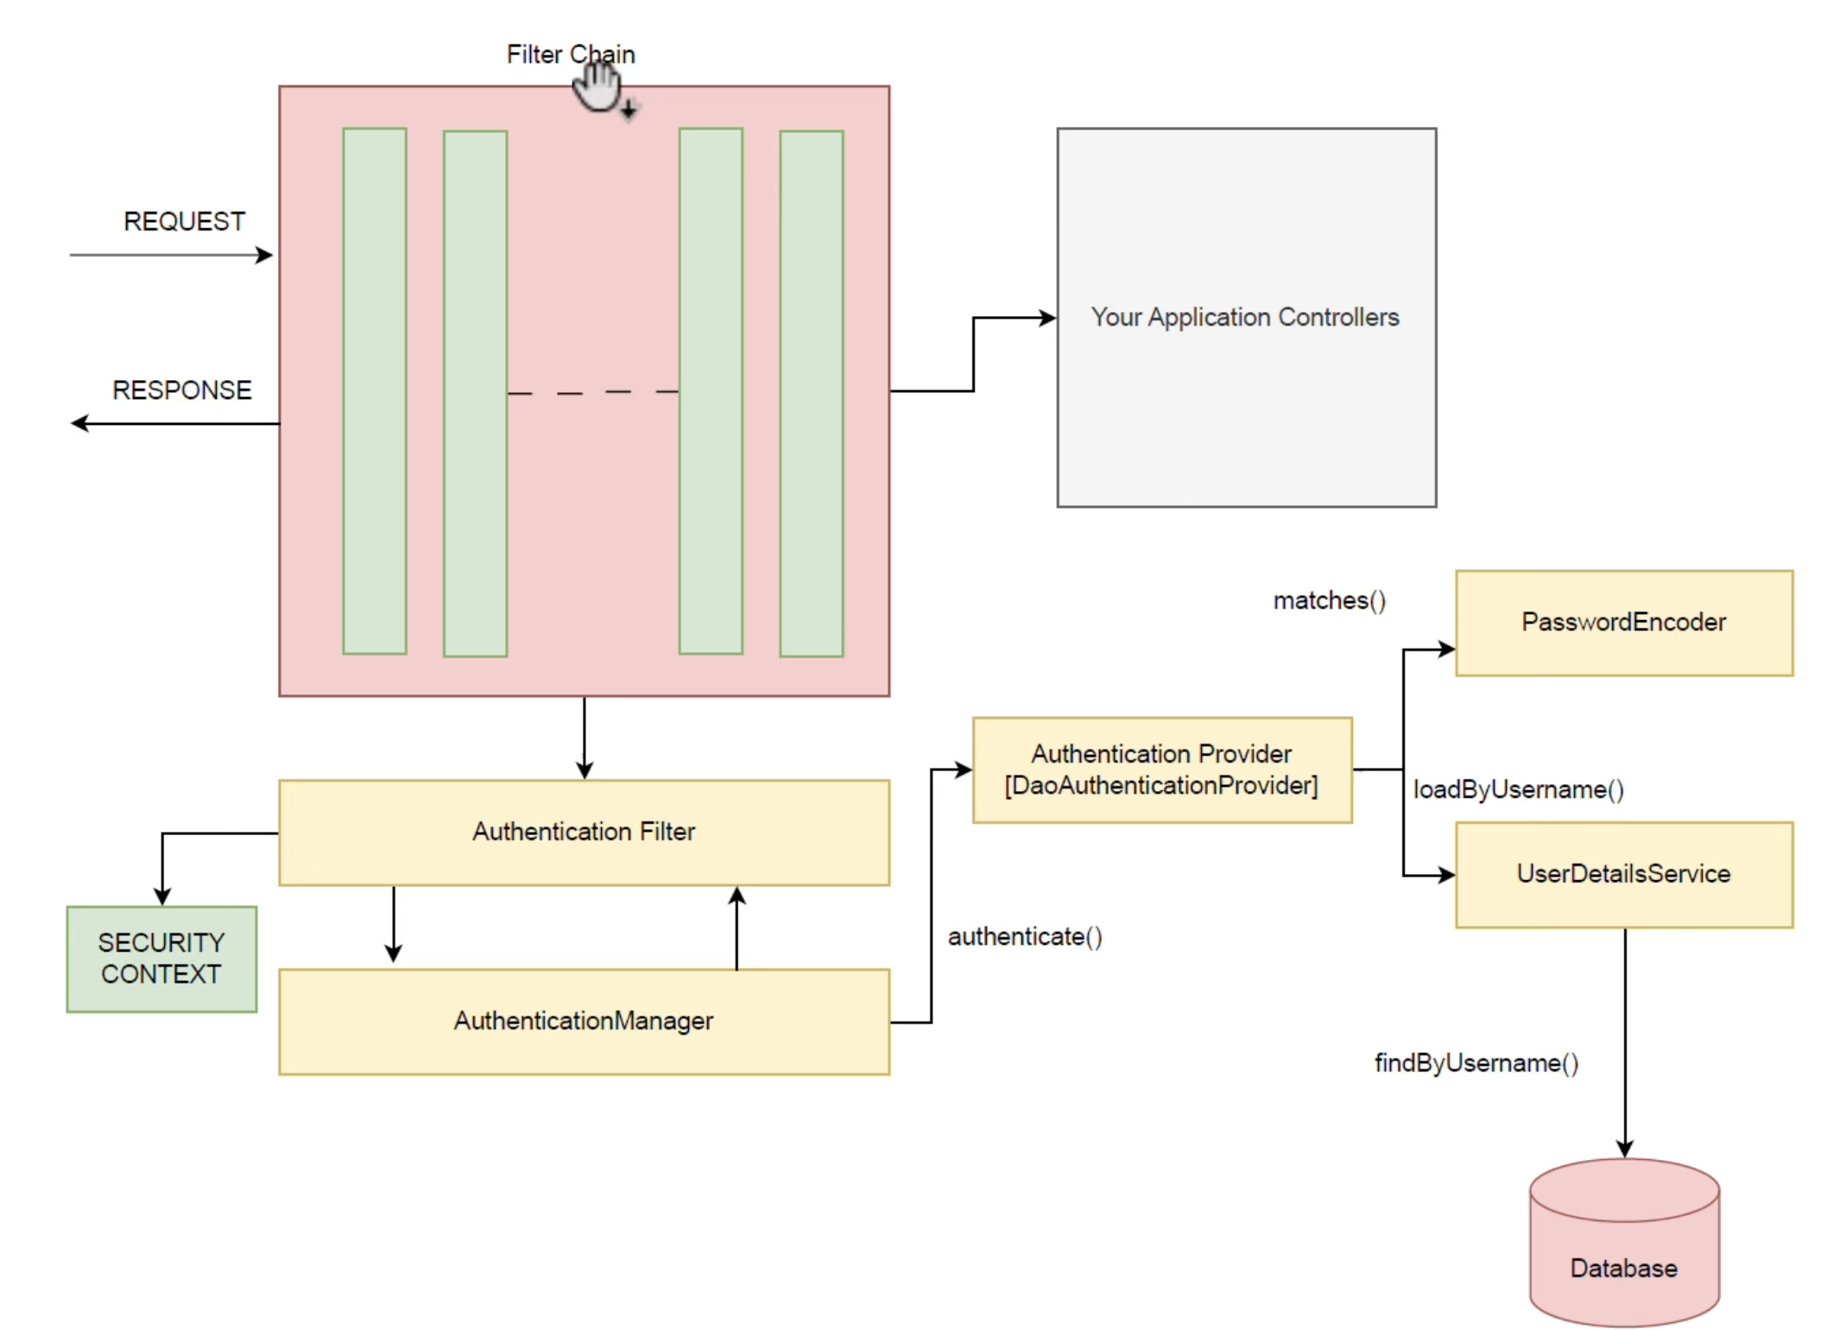

To make cookies stateless, we can add as below

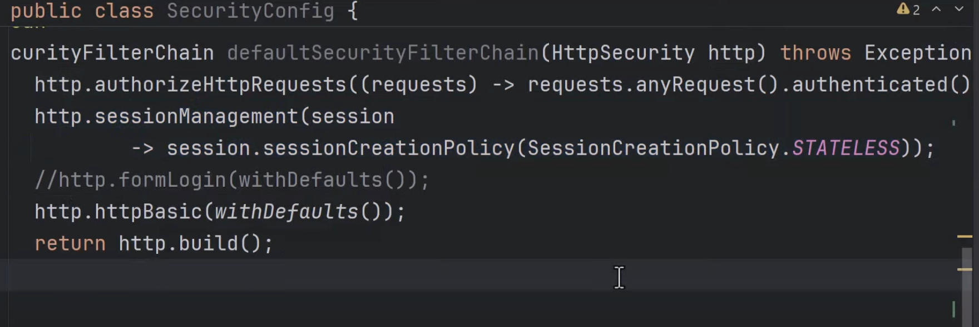

you can give user and password in application.properties. But if you want to use multiple user ids and passwords then you can use InMemoryDetailsManager as below

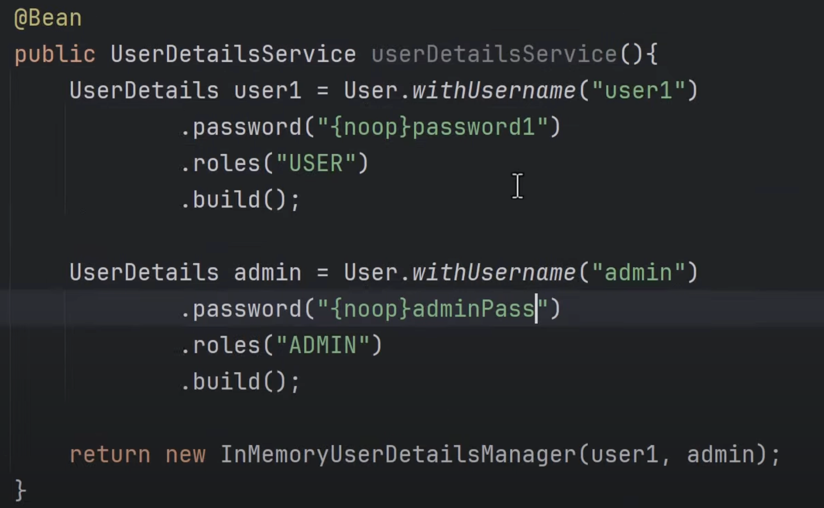

If we want to give authorization to a api access only the persona then need to do below

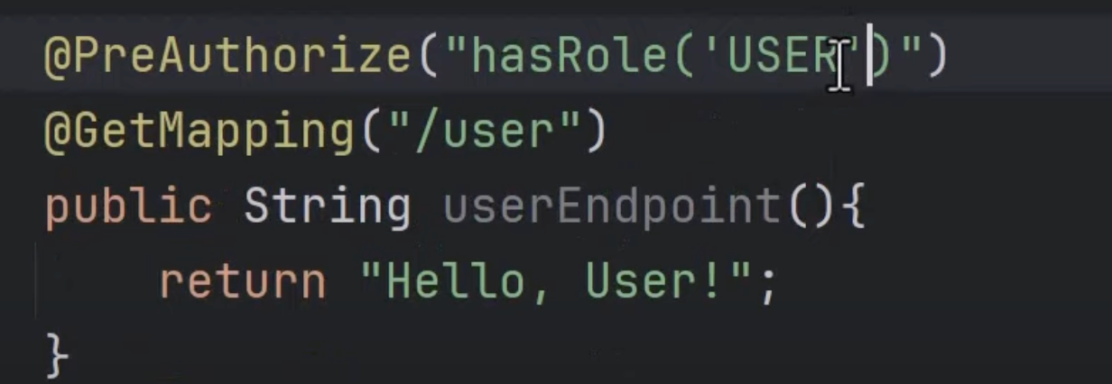

Also add @EnableMethodSecurity annotation

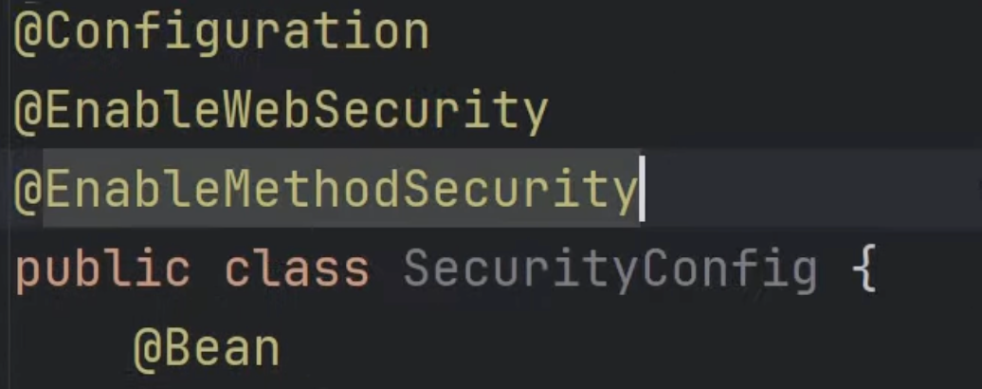

If you want to give permission to access to apis then we can do as below

And also csrf disable

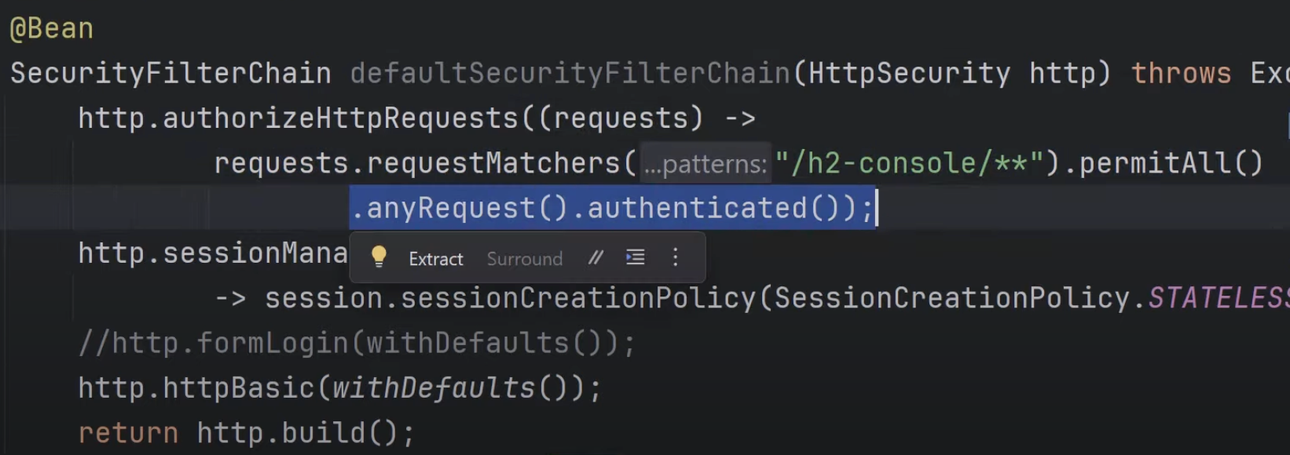

If we want to do with database rather than In memory we can do as below:

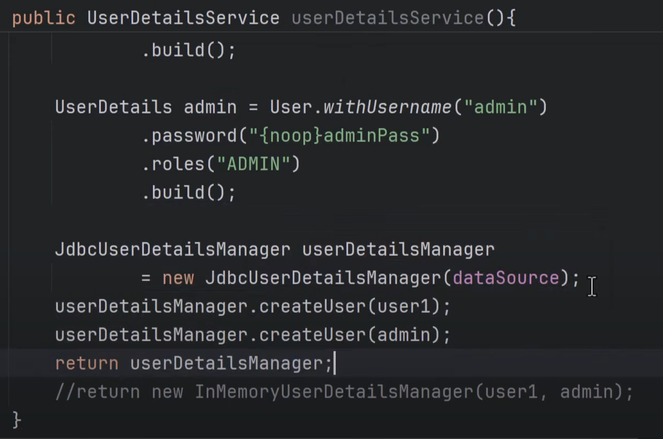

Need also add in schema.sql under resources

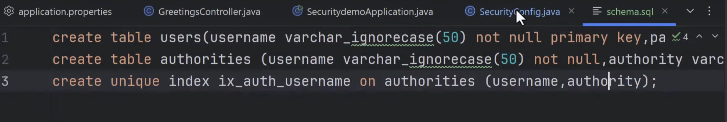

Salting is something which add some string after bcrypt in password

